**Meeting_6 Finalize ER Diagram, Data flow, Use case diagram and Review Activity diagram and State diagram**

DETAILS

* **Final Diagrams**
  + - Use case:

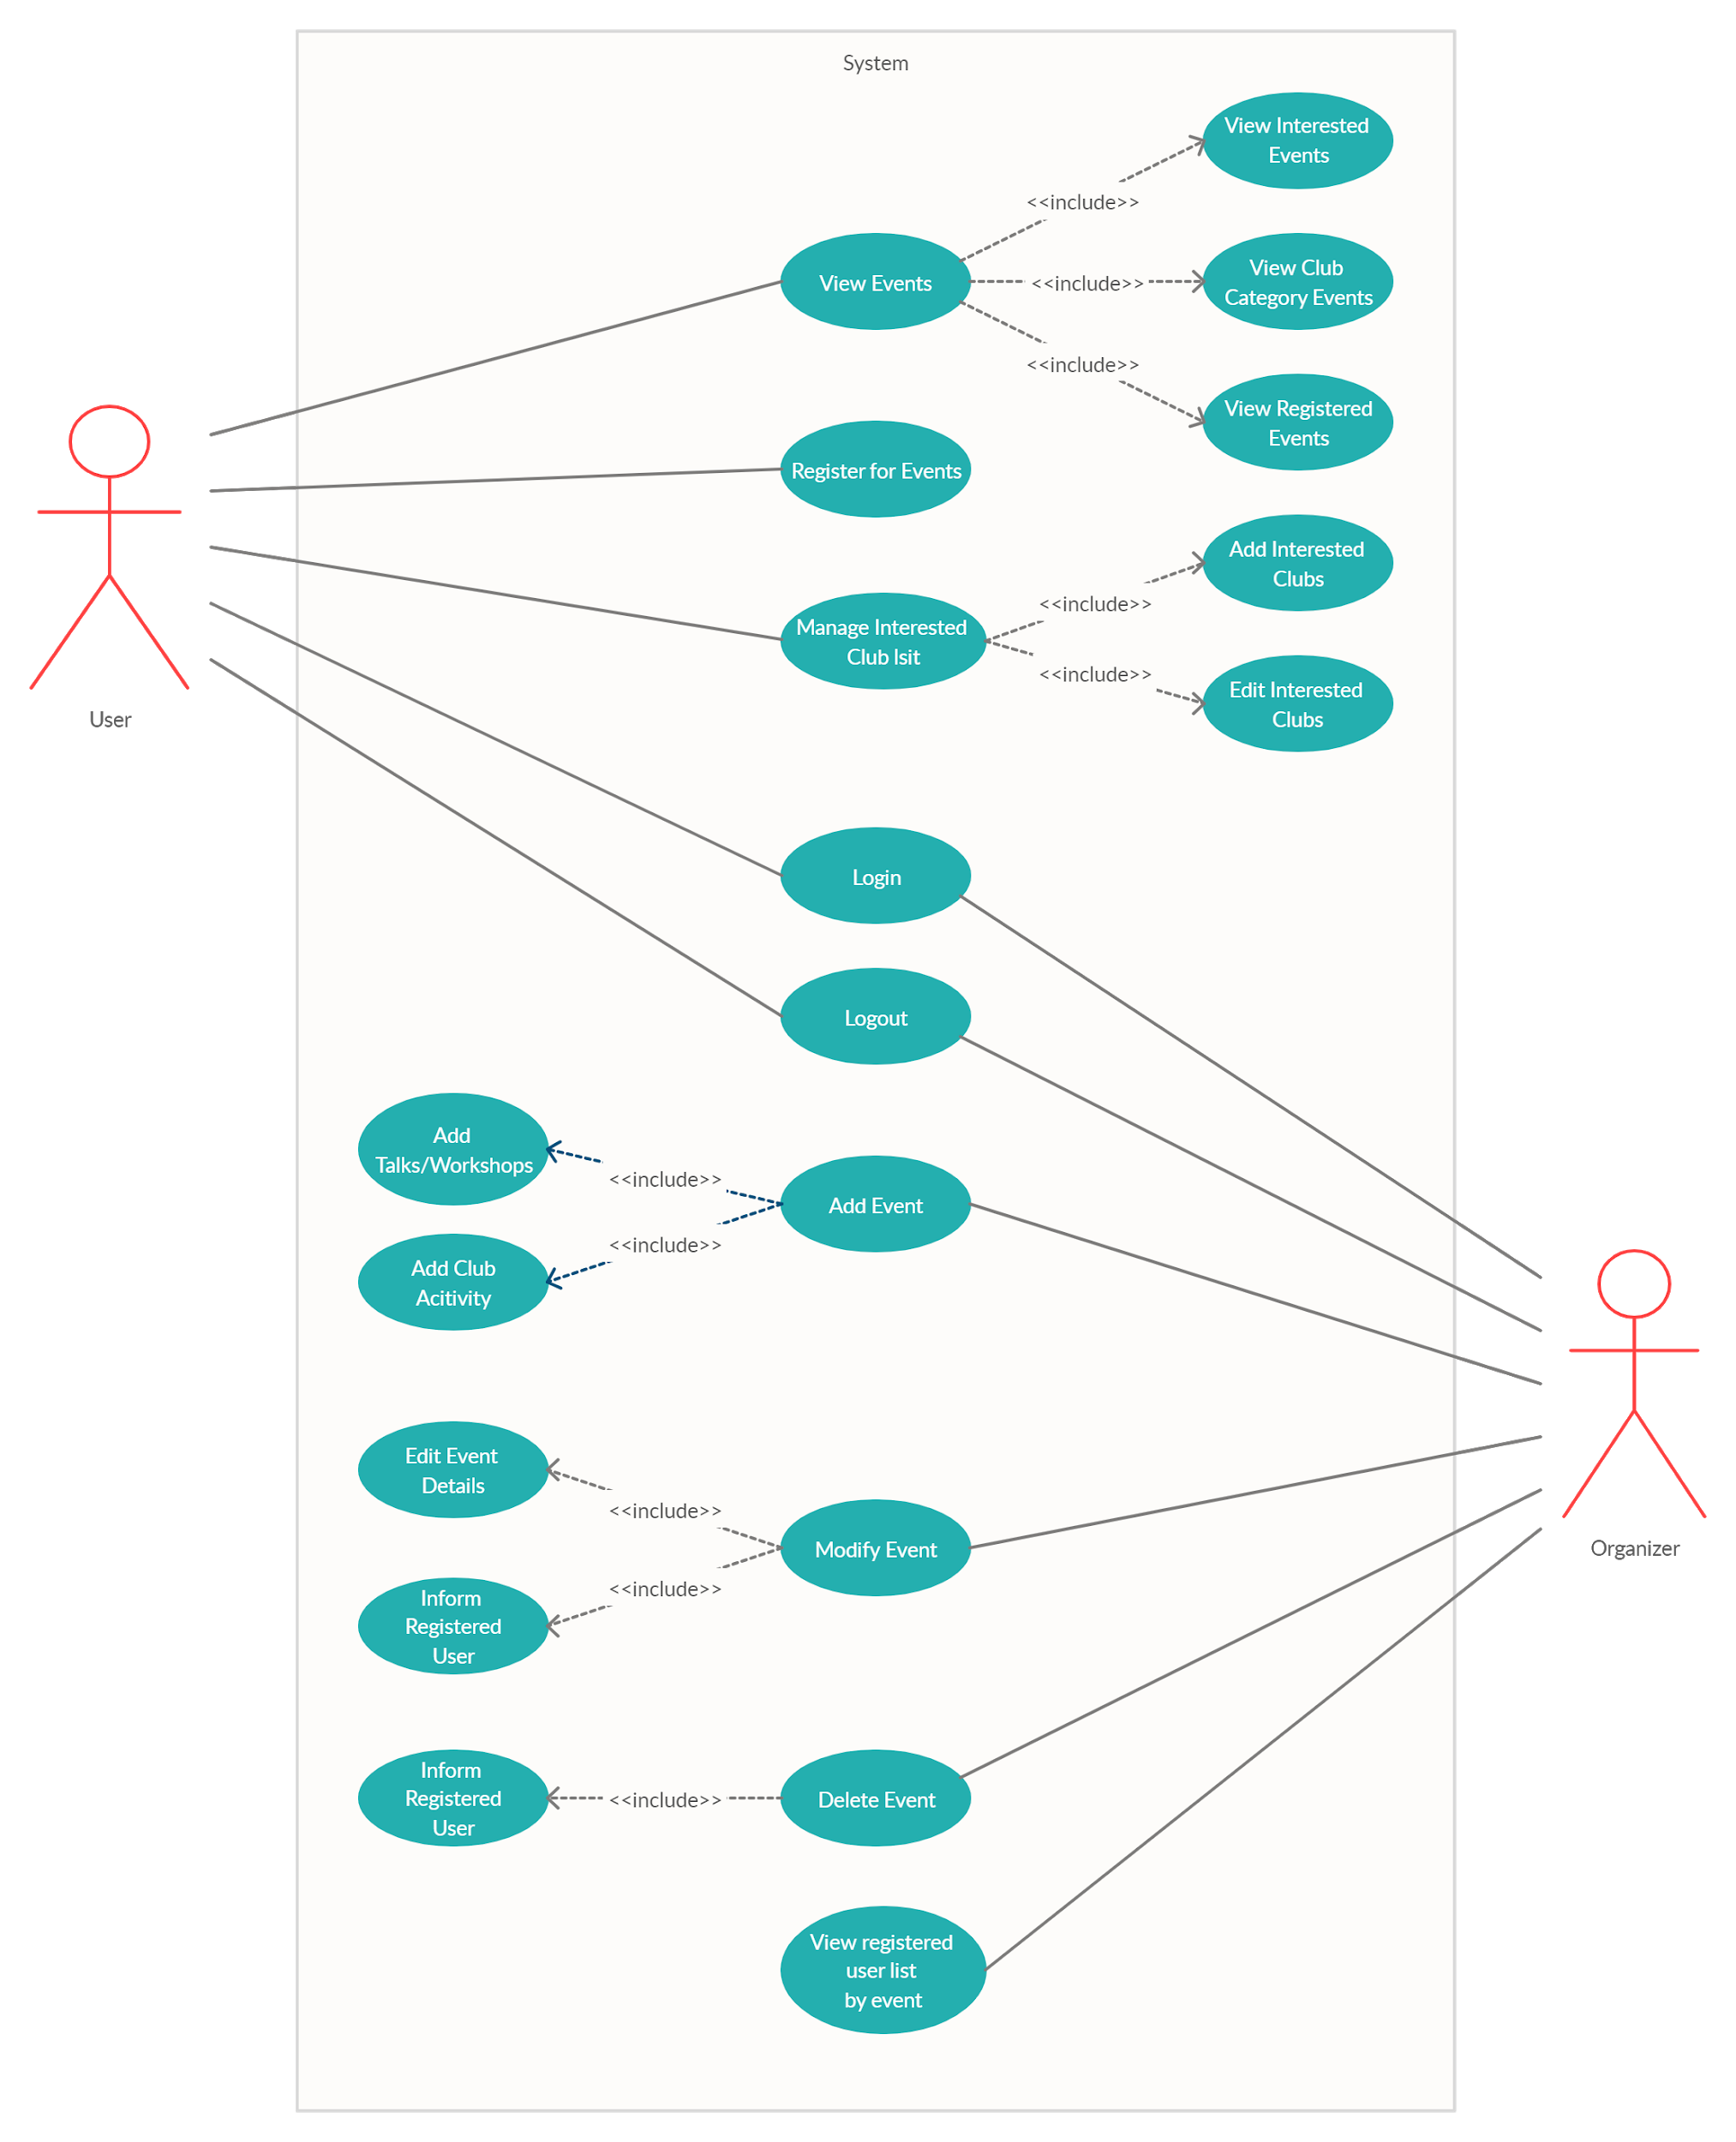

* + - ER diagram
      * + 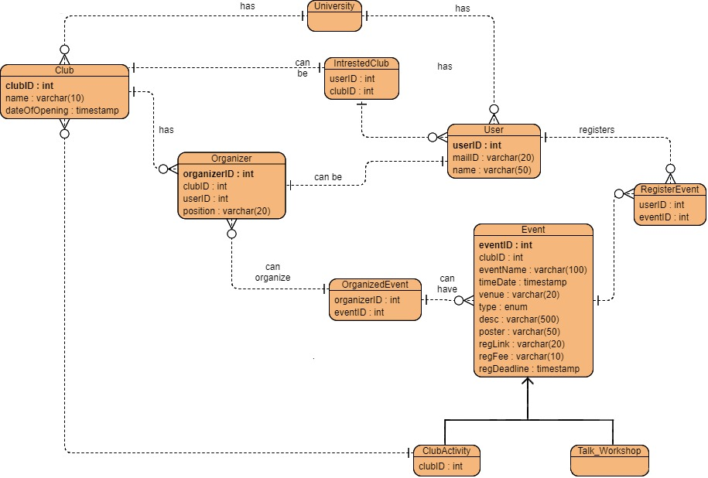
    - Data flow Diagram
      * + <https://drive.google.com/open?id=1UOmpqn0C7FLt9H-n1E6EWJLK5uBimsEp>
    - **Rough diagrams:**
    - State diagram
      * + 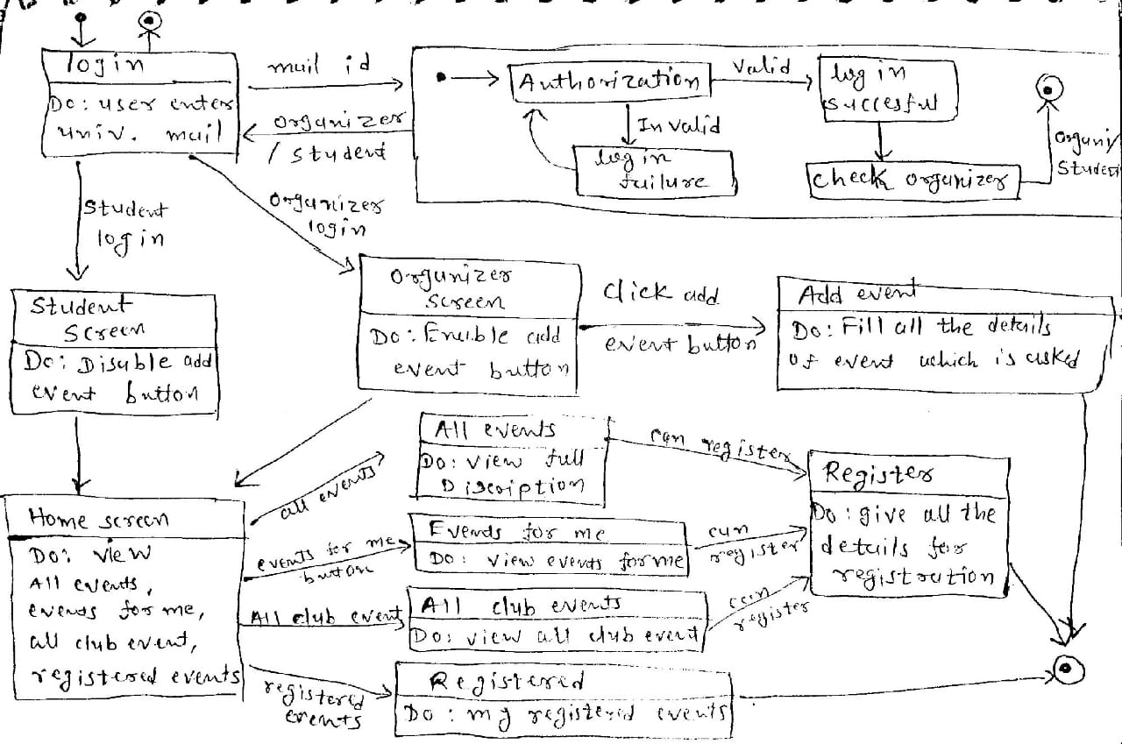
    - Activity diagram
      * + Sign in activity diagram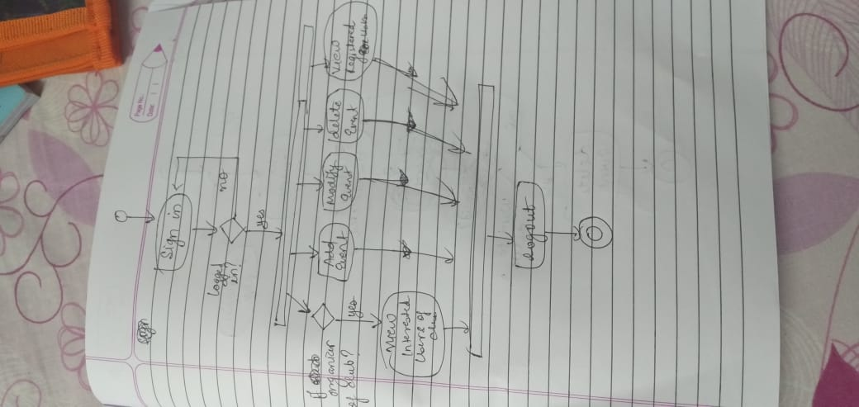

Organizer Activity diagram

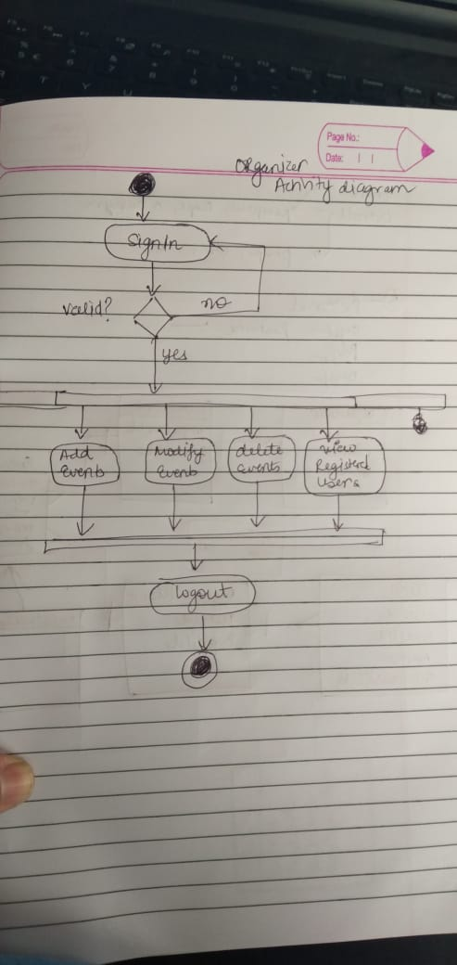

Add event activity diagram:

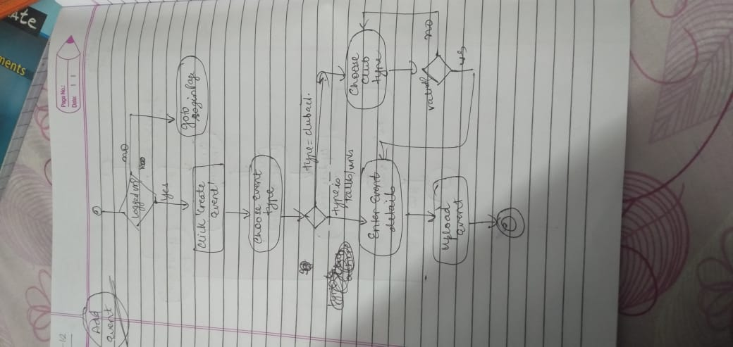

modify event activity diagram :

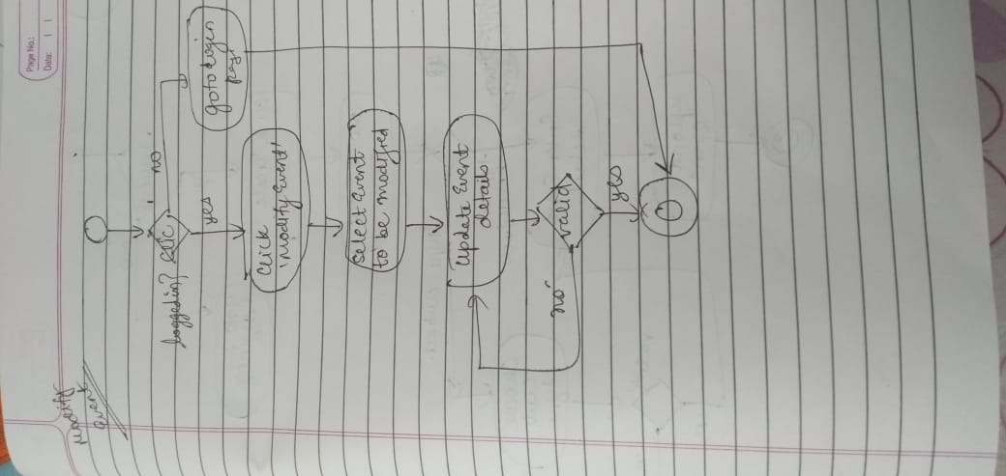

Delete event activity diagram :

